# **Problem statement:**

**(1)** Write a code snippet in Assembly to add two 16 bit numbers and multiply the result with another 16 bit number. If the 16 bit numbers are denoted by *A, B* and *C,* respectively, then you have to calculate *(A+B)*C*.

Declare three **word** type variables to store values of *A, B* and *C.* Additionally declare two more variables, ***S*** and ***P*** (make sure to properly initialize their sizes!) to store the results from *(A+B)* and *(A+B)*C,* respectively. For your convenience, a sample result has been provided to see if your code is working properly or not. You should also try out other values of *A, B* and *C* and cross check results from your code with an online available hexadecimal calculator.

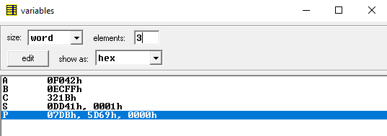**A** : F042H

**B** : ECFFH

**C** : 321BH

**S** : 0001H DD41H

**P** : 5D69H 07DBH

Prepare a **doc** file with the code alongside necessary screenshots and upload it in the relevant assignment in due time.

**(2)** Write a code snippet in assembly to multiply two 32 bit numbers.